**Abstract and learning objectives**

In this hands-on lab, you will implement a solution which combines both pre-built artificial intelligence (AI) in the form of various Cognitive Services, with custom AI in the form of services built and deployed with Azure Machine Learning service. You will learn to create intelligent solutions atop unstructured text data by designing and implementing a text analytics pipeline. You will discover how to build a binary classifier using a simple neural network that can be used to classify the textual data, as well as how to deploy multiple kinds of predictive services using Azure Machine Learning and learn to integrate with the Computer Vision API and the Text Analytics API from Cognitive Services.

At the end of this hands-on lab, you will be better able to implement solutions leveraging Azure Machine Learning service and Cognitive Services.

**Overview**

In this workshop, you will help Contoso Ltd. build a proof of concept that shows how they can build a solution that amplifies the claims processing capabilities of their agents.

**Solution architecture**

The high-level architecture of the solution is illustrated in the diagram. The lab is performed within the context of a notebook running within Azure Databricks. Various notebooks are built to test the integration with the Cognitive Services listed, to train custom ML services, and to integrate the results in a simple user interface that shows the result of processing the claim with all of the AI services involved.

[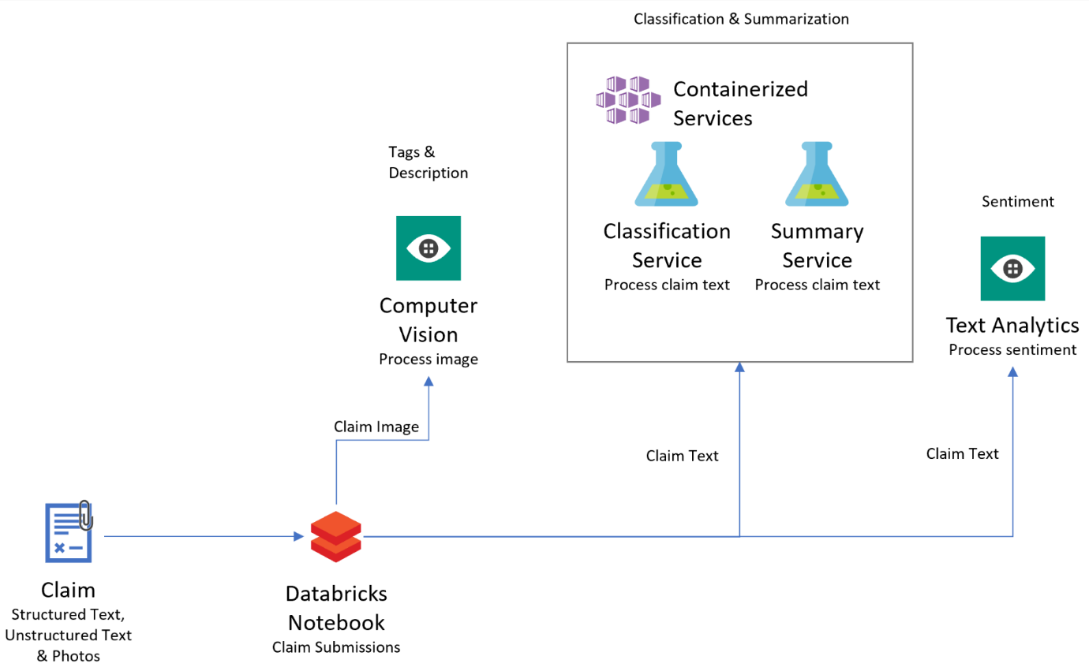](https://github.com/jumpstartninjatech/HeroSolutions-ML/blob/master/Day2/Cognitive-services-and-deep-learning/Hands-on%20lab/media/image2.png)

**Requirements**

1. Microsoft Azure subscription must be pay-as-you-go or MSDN

a. Trial subscriptions will not work. You will run into issues with Azure resource quota limits.

b. Subscriptions with access limited to a single resource group will not work. You will need the ability to deploy multiple resource groups.

**Exercise 1: Setup Azure Databricks Workspace**

Duration: 20 minutes

In this exercise, you will setup your Azure Databricks account and Workspace.

**Task 1: Provision Azure Databricks service**

1. Navigate to the Azure Portal.
2. Select **Create a resource**.

[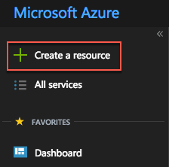](https://github.com/jumpstartninjatech/HeroSolutions-ML/blob/master/Day2/Cognitive-services-and-deep-learning/Hands-on%20lab/media/azure-portal-create-a-resource.png)

1. In the search box, enter **Azure Databricks** and then select the matching entry that appears with the same name.

[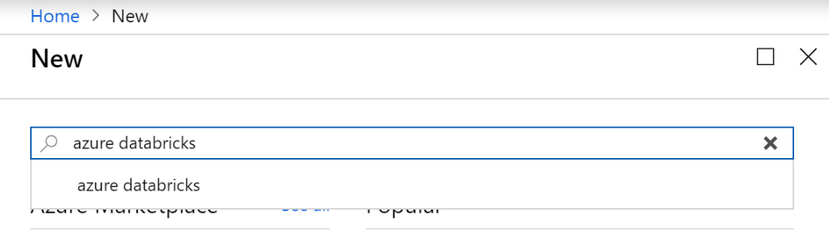](https://github.com/jumpstartninjatech/HeroSolutions-ML/blob/master/Day2/Cognitive-services-and-deep-learning/Hands-on%20lab/media/image3.png)

1. On the **Azure Databricks** blade, select **Create**.
2. On the **Azure Databricks Service**, enter the following and then select **Create**:

a. **Workspace Name**: Enter claims-workspace.

b. **Subscription**: Choose your Azure subscription.

c. **Resource group**: Choose Create new and then specify the name mcwailab.

d. **Location**: Choose a location near you.

e. **Pricing Tier**: Select Premium.

[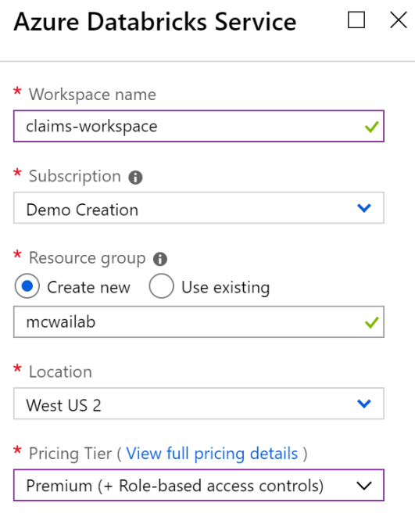](https://github.com/jumpstartninjatech/HeroSolutions-ML/blob/master/Day2/Cognitive-services-and-deep-learning/Hands-on%20lab/media/image3-1.png)

1. When the deployment completes, navigate to your deployed Azure Databricks service and select **Launch Workspace**. If prompted, sign in using the same credentials you used to access the Azure Portal.

[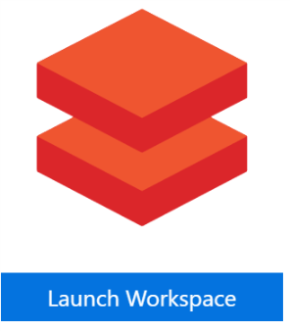](https://github.com/jumpstartninjatech/HeroSolutions-ML/blob/master/Day2/Cognitive-services-and-deep-learning/Hands-on%20lab/media/image3-2.png)

**Task 2: Upload the Databricks notebook archive**

1. Within the Workspace, using the command bar on the left, select Workspace, Users and select your username (the entry with house icon).
2. In the blade that appears, select the downwards pointing chevron next to your name, and select Import.
3. On the Import Notebooks dialog, select URL and paste in the following URL:
4. https://github.com/Microsoft/MCW-Cognitive-services-and-deep-learning/blob/master/Hands-on%20lab/media/notebooks/AI-Lab.dbc?raw=true
5. Select Import.
6. A folder named after the archive should appear. Select that folder.
7. The folder will contain one or more notebooks. These are the notebooks you will use in completing this lab.

**Task 3: Provision a cluster**

1. Within the Workspace, from the menu on the left, select Clusters.
2. Select **+ Create Cluster**.
3. On the New Cluster page, provide the following:

a. **Cluster Name**: ailab

b. **Cluster Mode**: Standard

c. **Databricks Runtime Version**: 5.3 (includes Apache Spark 2.4.0, Scala 2.11)

d. **Python Version**: 3

e. **Driver Type**: Same as worker

f. **Worker Type**: Standard_F4s

g. **Enable autoscaling**: Unchecked

h: **Workers**: 2

[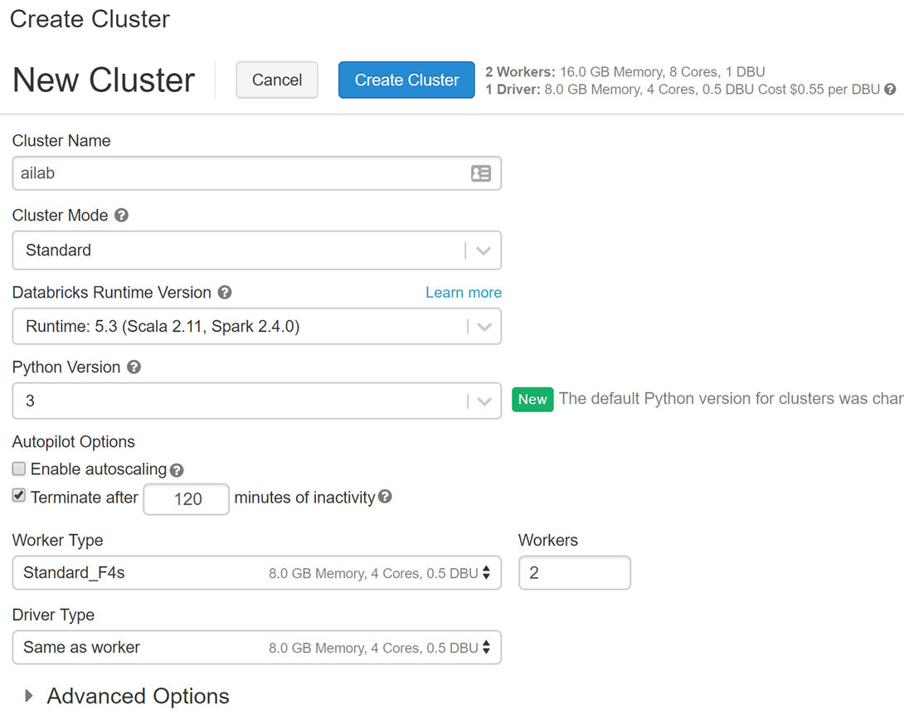](https://github.com/jumpstartninjatech/HeroSolutions-ML/blob/master/Day2/Cognitive-services-and-deep-learning/Hands-on%20lab/media/image3-3.png)

1. Select **Create Cluster**. This will take about 5 minutes to provision your cluster. The cluster will show a State of "Ready" when the cluster is available for use.